Moffett 1
A Moffett
Mr. Brown
English Language Arts
March 2nd 2016
Have you ever heard of an animal that is cat-like, as well as dog-like? A mammal that lives in Madagascar? An animal that will hunt day or night?

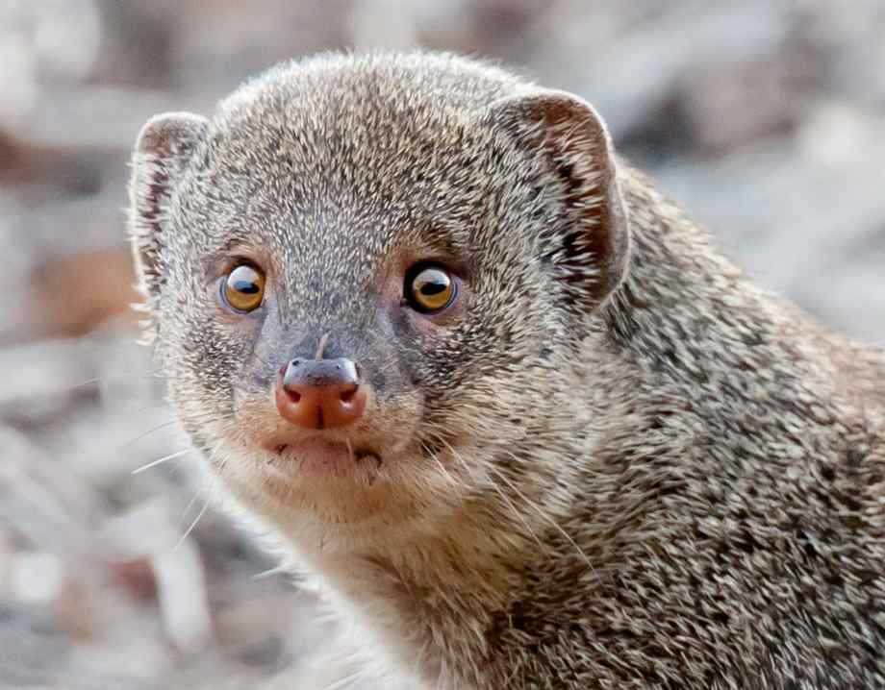
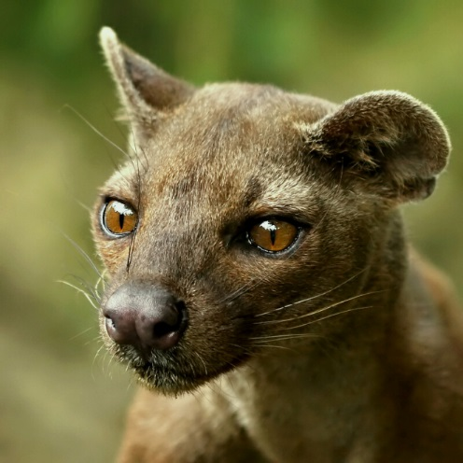
If you said fossa, then you were right! The fossa is a relative of the mongoose, however, it has a look all for itself. Uniquely, it looks more cat-like, with a dog-like muzzle. This mammal (a mammal is an animal that drinks its mother’s milk) can grow up to six feet, and can weigh up to twenty-six pounds. Typically, males are larger than females. The fossa has reddish brown fur, and a tail that’s about as long as it’s body!
Fossa
Mongoose

Moffett 2
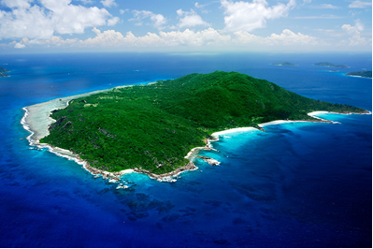
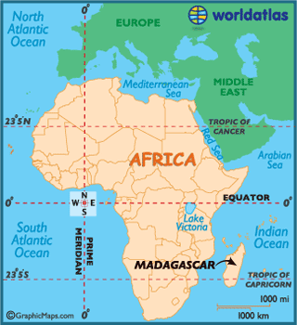
Secondly, the fossa lives in Madagascar, which is an African island. Less than ten percent of Madagascar’s original forest, the fossa’s habitat, is still left. Therefore, it is becoming an endangered animal. You can usually find the fossa in humid forests more often than dry ones, while you can still find them throughout all different kinds of forests on the island. It seems as though fossa can navigate easier in humid forests, and dry forests have less shade because of low canopy, so perhaps this is why they prefer humid forests. You can find these solitary creatures up to two thousand meters above the ground!
Madagascar

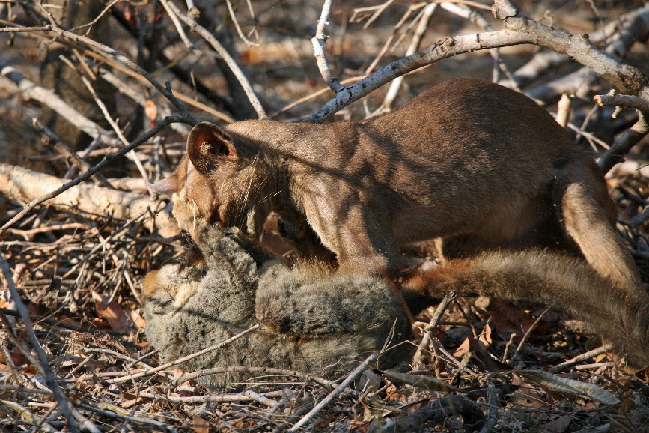
Next of all, the fossa is the largest carnivore (eats meat) and predator (hunts other animals) native to its island. With its retractable claws and cat-like teeth, the fossa can pretty much eat whatever it wants. In addition to this, over fifty percent of its diet consists of lemurs. The fossa will also eat wild pigs and mice. Although it is a nocturnal animal, (sleeps during the day, then comes out at night) the fossa will hunt day or night.
A fossa, hunting a lemur.
Moffett 3
To conclude with, you now know just some of the things that make this animal - that has both the qualities of cats as well as dogs - so intriguing. This mammal, with its interesting diet and the fact that it will hunt either day or night, would be a great animal to do a project on. With the information you’ve just read, you could write your very own descriptive report!

Moffett 4
Bibliography
A-Z Animals
http://a-z-animals.com/animals/fossa/
(February 22 2016)

Eyos Expeditions
http://www.eyos-expeditions.com/destinations/seychelles-and-madagascar/
(February 26 2016)

National Geographic:
http://animals.nationalgeographic.com/animals/mammals/fossa/
(February 17 2016)

Northrup Photography
http://www.northrup.org/photos/mongoose/
(February 24 2016)

Reef and Rainforest Tours:
https://reefandrainforest.files.wordpress.com/2015/01/fossa-kill-2.jpg
(March 1 2016)

Wikipedia:
https://en.wikipedia.org/wiki/Fossa_(animal)
(February 17 2016)

Wired:
http://www.wired.com/2015/01/creature-feature-10-fun-facts-fossa/
(February 17 2016)

World Atlas :
http://www.worldatlas.com/webimage/countrys/africa/mg.htm
(March 1 2016)

